# Project Name: myPortfolio: Easy Way to Create Your Amazing Portfolio.

## GitHub Link:

## <https://github.com/tamasjit/myjavaproject/tree/master/Phase%204/Phase-4_Practice_Project/q3_myPortfolio_Easy_Way_to_Create_Your_Amazing_Portfolio/portfolio>

## Output:

### Landing Page:



### Sign Up page:

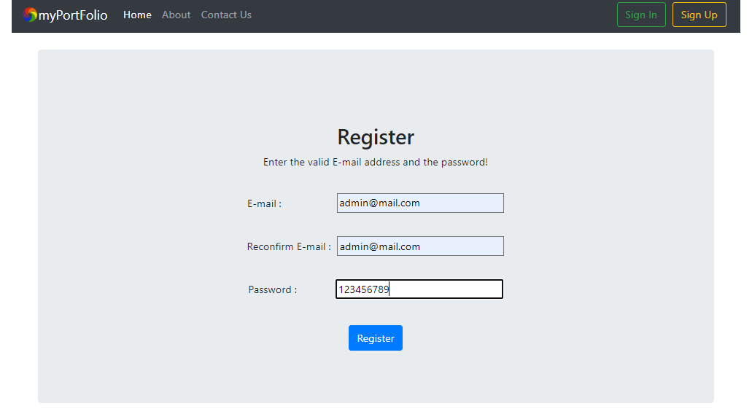

### Sign In page:

